A000-Asia-China-Liangzhu-Trapezoid-Pei Figure-Jade-3300-2250 BCE

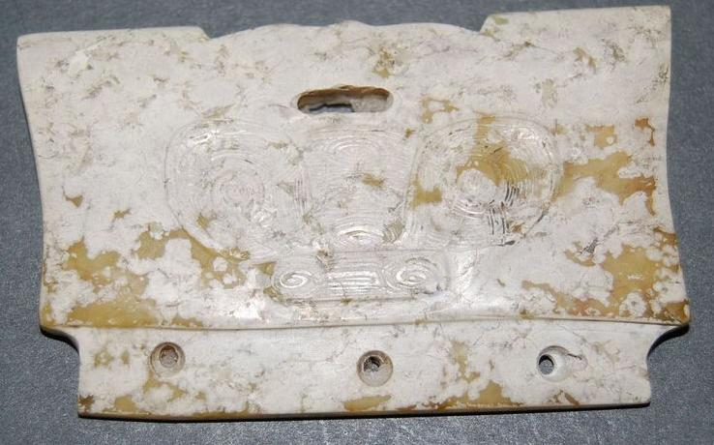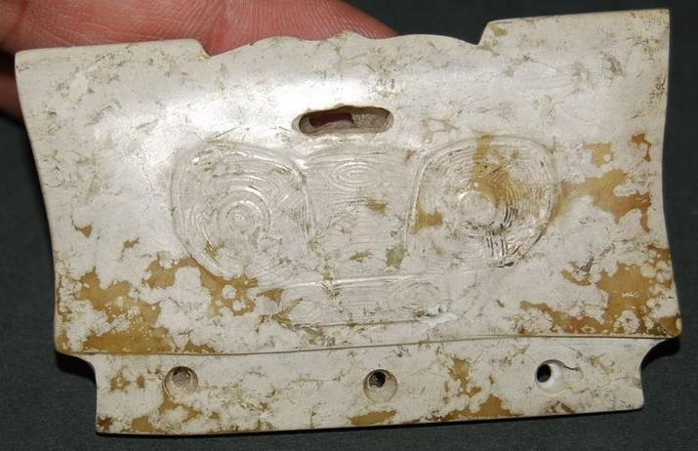

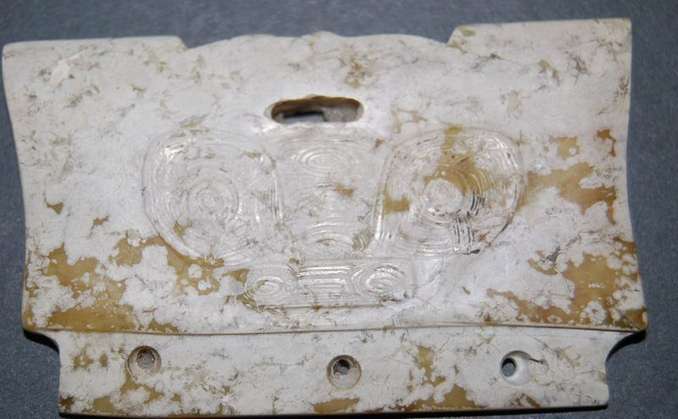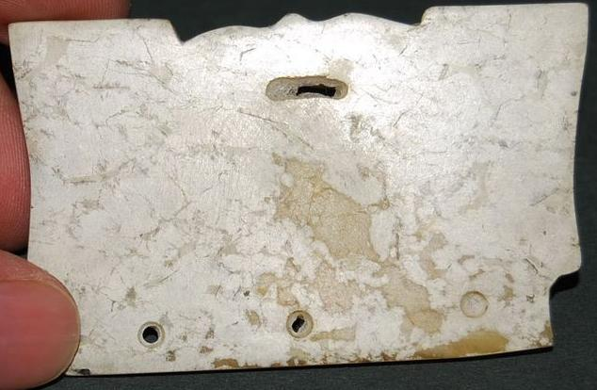

A000-Asia-China-Liangzhu-Trapezoid-Pei Figure-Jade-3300-2250 BCE

Figs. 1-4. Liangzhu-Trapezoid-Pei Figure-Jade-3300-2250 BCE

Case no.: 5

Accession Number:

Formal Label: Liangzhu-Trapezoid-Pei Figure-Jade-3300-2250 BCE

**Display Description:** Jade Pei objects were used in headdresses with other jade pieces and with decorative feathers. The visage on the recto of this piece is suggestive of visages carved in larger cong and so might have a connection with ancestor worship. Pei figurines have been found carefully laid on the bodies of the deceased.

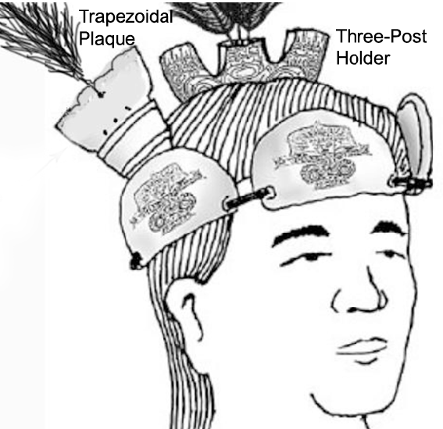

Fig. 5. Reconstruction of how the Three-Post Holder and the Trapezoidal Plaque (Pei) were attached to combs. After Gu 2005.8:69; revised detail after Childs-Johnson 2009, fig.17, p. 352. The feathers indicate the Heavenly movement of Earth around the Pole Star.

Comparable trapezoidal comb ornaments have been identified. One has three perforations and a centrally located top perforation and is in the Shanghai Museum:

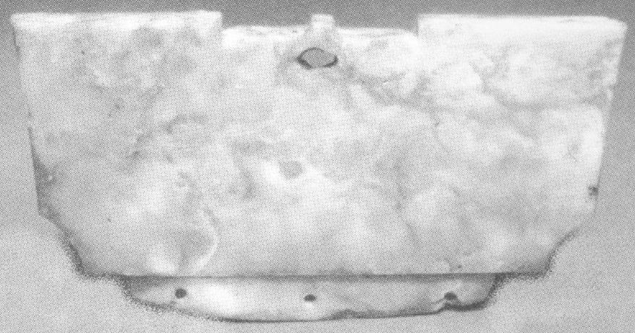

Fig. 6. Trapezoidal comb ornament, southeast China, late Neolithic Period, Liangzhu culture, ca. 3200-2300 BCE, probably of the Songze culture in the Shanghai region, Shanghai Museum. Dimensions not given. After Childs-Johnson 1988, no. 68, p. 21b. Another trapezoidal comb ornament with two perforations and a top central hole is in the collection of Richard J Salisbury, New Jersey:

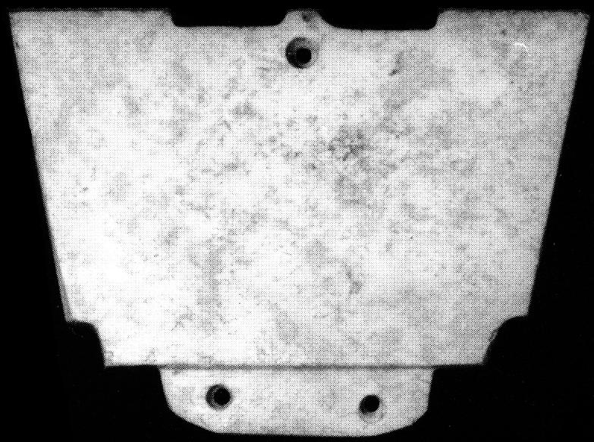

Fig. 7. Trapezoidal comb ornament, southeast China, late Neolithic Period, Liangzhu culture, ca. 3200-2300 BCE, , Richard J Salisbury Collection, New Jersey. 4.7 cm. high, 6.5 cm. wide, 0.5 cm. thick. After Childs-Johnson 1988, no. 68a, p. 21. Other trapezoidal comb ornaments were documented through archaeological excavations at Yaoshan and Fanshan:

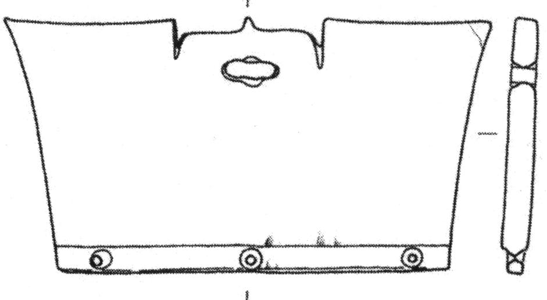

Fig. 8. Trapezoidal comb ornament from Yaoshan, E 3-3, M12: 2850, after Childs-Johnson 2009, Fig. 15, p. 344.

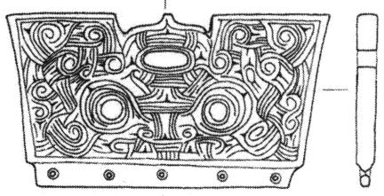

Fig. 9. Trapezoidal comb ornament, decorated with apotropaic mask face, from Yaoshan, E 3-4, M11: 86, after Childs-Johnson 2009, Fig. 15, p. 344.

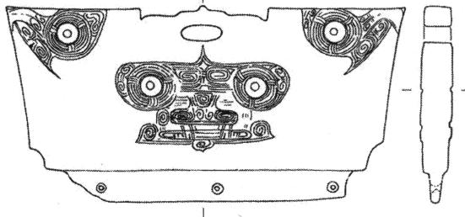

Fig. 10. Trapezoidal comb ornament, decorated with apotropaic mask face and two eye motifs, from Fanshan, E 3-5, M22:11, after Childs-Johnson 2009, Fig. 15, p. 344.

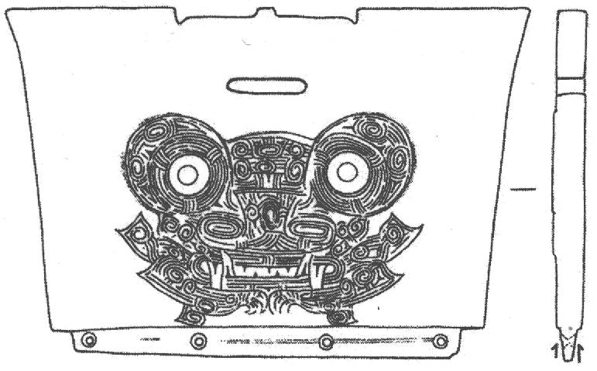

Fig. 11. Trapezoidal comb ornament, decorated with apotropaic mask face, from Fanshan, E 3-2, M17:8, after Childs-Johnson 2009, Fig. 15, p. 344.

**LC Classification:** NK5750.2.A1

Date or Time Horizon: Liangzhu culture, lower Yangzi River Valley, 3300-2250 BCE

Geographical Area: Liangzhu culture, lower Yangzi River Valley

**Map:**

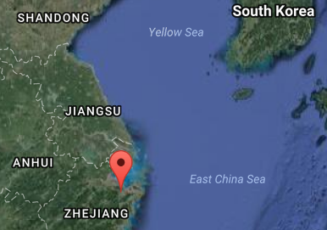

Fig. 12. Location the Liangzhu site proper.Source: Google Earth

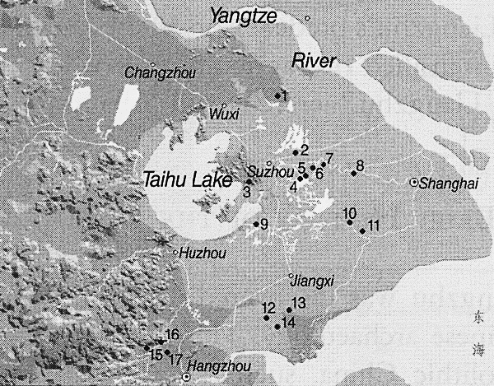

Fig. 13. Detail of Liangzhu site complex surrounding Taihu. After Zhou Ying 2007.

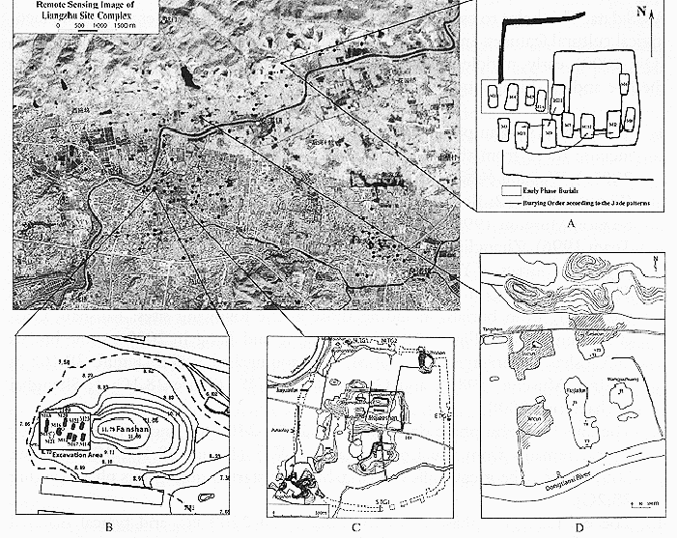

**Fig. 14.** Detail of Liangzhu site proper. After Zhou Ying 2007.

**GPS coordinates:**

Northeast corner: N 30°24'48", E 120°00'17"

Northwest corner: N 30°24'41", E 119°58'58"

Southeast corner: N 30°23'20", E 120 00'19"

Southwest corner: N 30°22'55", E 119°58'28"

Cultural Affiliation: Liangzhu culture, lower Yangzi River Valley, 3300-2250 BCE

Medium: Jade

Dimensions: H: 5.8 cm. x W: 3.4 cm.

Weight:

Condition: original

Provenance:

**Discussion:**

Liangzhu (3400–2250 BCE) in Yuhang County, Zhejiang, was a highly stratified Neolithic jade city-state in the Yangtze River delta where élites controlled a sphere of influence north to Shanxi and south to Guangdong. Jade and other expensive wares (such as silk, lacquerware, and ivory) characterized the social symbolism of Liangzhu élites which they used in ritual performances and dances as well as in grave goods..

DNA from Liangzhu culture sites that existed around Taihu Lake and the mouth of the Yangtze River exhibit high frequencies of Haplogroup O1 which was absent in other archaeological sites inland. Haplogroup O1 is common to modern Austronesians. The Taiwanese Aborigines/Taiwanese Austronesians (TAN) (O1) probably came from those Liangzhu Austronesians (LAN) who were displaced from Southern China by the demise of the LAN perhaps induced by the meteor of ca 4500 BCE that struck at the location of Taihu Lake. LAN culture sites that existed around Taihu Lake and the mouth of the Yangtze River were at risk from such an event, and by ca 4200 BP LAN succumbed to a series extreme floods that interrupted the cultural layers with intrusions of mud and sand.

**References:**

Biot, Jean Baptiste. 1851. *Le Tcheou-li: ou, Rites des Tcheou*. Paris: Imprimerie nationale, 1851. 3v.

Chang, K.C., Xu, P. and Lu, L. 2005. *The formation of Chinese civilization: an archaeological perspective*. New Haven: Yale University Press.

Childs-Johnson, Elizabeth. 1988. *Ritual and Power: Jades of Ancient China*. New York: China House Gallery, China Institute in America.

Childs-Johnson, Elizabeth. 2009. The Art of working Jade and the rise of civilization in China. In Elizabeth Childs-Johnson, *Early Chinese jades in American Museums.* Beijing: The Science Press, China Science and Technology Publishing and Media Co., Ltd., 2009, pp. 291-393.

Gu Fang. 2005. *Complete collection of unearthed jades in China*. 15 v. Beijing: China Science and Technology Publishing and Media Co., Ltd.

Hayashi, Minao. INCLUDEPICTURE "http://lms01.harvard.edu:80/exlibris/aleph/u20_1/alephe/www_f_eng/icon/f-separator.gif" \* MERGEFORMATINET INCLUDEPICTURE "http://lms01.harvard.edu:80/exlibris/aleph/u20_1/alephe/www_f_eng/icon/f-separator.gif" \* MERGEFORMATINET INCLUDEPICTURE "http://lms01.harvard.edu:80/exlibris/aleph/u20_1/alephe/www_f_eng/icon/f-separator.gif" \* MERGEFORMATINET 林巳奈夫. 1991. *Chūgoku kogyoku no kenkyū*. INCLUDEPICTURE "http://lms01.harvard.edu:80/exlibris/aleph/u20_1/alephe/www_f_eng/icon/f-separator.gif" \* MERGEFORMATINET INCLUDEPICTURE "http://lms01.harvard.edu:80/exlibris/aleph/u20_1/alephe/www_f_eng/icon/f-separator.gif" \* MERGEFORMATINET INCLUDEPICTURE "http://lms01.harvard.edu:80/exlibris/aleph/u20_1/alephe/www_f_eng/icon/f-separator.gif" \* MERGEFORMATINET 中國古玉の研究. Tōkyō : Yoshikawa Kōbunkan; 東京 : 吉川弘文館, 1991.

Hayashi, Mineo. 1990. “On the Chinese Neolithic jade Tsung/Cong,” *Artibus Asiae*, 50(1/2):5-22.

Hayashi, Mineo. 1973. *Toyo Gakuho* [Journal of the Research Dept. of the Toyo Bunko] 45:1-57.

Laufer, Berthold. 1912. *Jade a study in Chinese archaeology and religion*. Field Museum of Natural History, Publication 154, Anthroplogical series, vol. X. Chicago.

Li, Hui; Huang, Ying; Mustavich, Laura F.; Zhang, Fan; Tan, Jing-Ze; Wang, ling-E; Qian, Ji; Gao, Meng-He; Jin, Li. 2007. "Y chromosomes of prehistoric people along the Yangtze River," Human Genetics **122**: 383–388.

Lu Wenbao. 1998. Cong-shaped bead. In Liangzhu Culture Museum, ed., The dawn of Chinese civilization: Jades of the Liangzhu culture. Hong Kong: Liangzhu Culture Museum and The Art Museum, The Chinese University of Hong Kong.

Wu, Li. 2014. "Holocene environmental change and its impacts on human settlement in the Shanghai Area, East China," Catena. **114**: 78–89

Zhang, Chia; Hsiao-Chun, Hung. 2008. "The Neolithic of Southern China–Origin, Development, and Dispersal,"Asian Perspectives. **47**:2, 309–310.

|  |
| --- |
| Zhou Ying. 2007. 东方文明的曙光: 良渚遗址与良渚文化 = Dong fang wen ming de shu guang : Liang zhu yi zhi yu liang zhu wen hua = *The Dawn of the Oriental Civilization: Liangzhu site and Liangzhu culture*. Beijing: China Intercontinental Press. |